Hope for Justice and Slave-Free Alliance: Scale and operations

Hope for Justice is a global charity founded in the UK in 2008 that is working to end modern slavery and human trafficking with an effective, proven multi-disciplinary model that is replicable, scalable, and widely admired. Slave-Free Alliance is Hope for Justice’s business-focused division, founded in 2018.

With more than 350 employees working from 30+ locations across five continents, Hope for Justice & Slave-Free Alliance is one of the world’s biggest non-profit organisations in the anti-trafficking sector by headcount, revenue and number of beneficiaries.

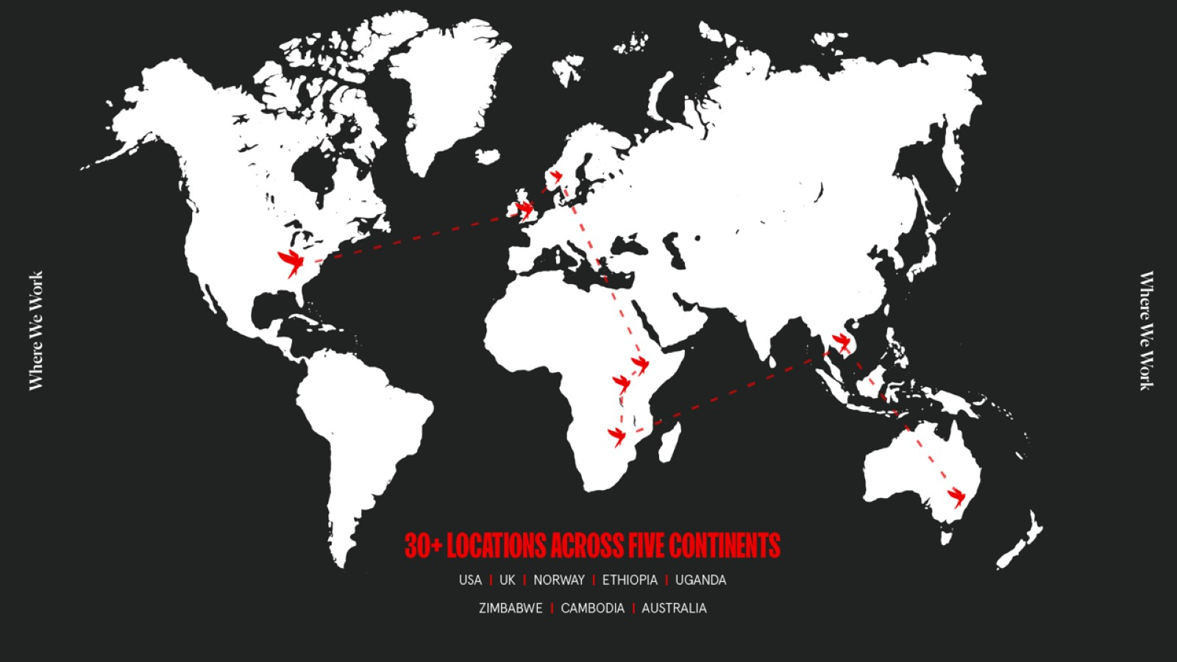

Impact

In FY2020-21, the charity’s work reached 192,667 children and adults. This included:
- 4,844 people – Rescued from human trafficking and modern slavery, helped through outreach or provided with aftercare after rescue
- 21,170 people – Had formal training or engaged with Hope for Justice community prevention work
- 166,653 people – Attended awareness events or received indirect support from Hope for Justice
These results were certified by the organisation’s Monitoring, Evaluation, Research and Learning (MERL) division which produces quantitative and qualitative reports into performance and promotes continuous improvement.
International and Governmental Influence

This direct work with victims and survivors informs Hope for Justice and Slave-Free Alliance’s work on national and international policy reform and legislative engagement, creating long-term sustainable frameworks for an anti-slavery ecosystem. Hope for Justice and/or Slave-Free Alliance are represented on the following national and international steering committees and policy co-ordination groups:

- International Anti Human Trafficking Advisory Group
- United Nations University: Delta 8.7 Alliance + Justice Policy Group
- Lichtenstein Initiative (Finance Against Slavery and Trafficking)
- Norway: Coordination Unit for Victims of Trafficking
- UK Home Office: Modern Slavery Strategy and Implementation Groups (MSSIGs) on:
  - Prevention (Co-chair)
  - Victim Care
  - Law Enforcement
  - International Group
  - Transparency in Supply Chains
- UK Home Office Oversight Group for the National Modern Slavery Statutory Guidance on Identification and Care
- London Mayor’s Office for Policing and Crime on Modern Slavery Strategy
- Advisory Group on National Training Standards
- UK Home Office Group on Developing Modern Slavery Training
- UK Home Office Vulnerability Group
- Anti Trafficking Monitoring Group
- Human Trafficking Foundation Network
- UK Independent Anti-Slavery Commissioner Steering Group on best practice
- Utilities Modern Slavery Working Group (Hosted by Slave-Free Alliance)
- Waste & Recycling Modern Slavery Working Group (Hosted by Slave-Free Alliance)
- Indirect Procurement Human Rights Group
- Home Office Group on Public Procurement
- Apparel and General Merchandise Public and Private Protocol – Participating Organisations (Hope for Justice and Slave-Free Alliance)

Strategy for Rapid Growth

Underpinned by a Theory of Change, Hope for Justice and Slave-Free Alliance are in the process of implementing a 10 Year Strategy to deliver rapid growth and scale in order to help more people.
In 2020-21, Hope for Justice and Slave-Free Alliance ran 29 global programmes across 7 countries, with programmes also implemented through a partner in an eighth country (Zimbabwe)

Strategic analysis and evaluation data have provided estimates showing that once Hope for Justice and Slave-Free Alliance’s 10 Year Strategy is fully implemented, the organisation’s charitable programmes will reach more than 1.2 million beneficiaries annually. This would mean that its work is having ten times the impact versus 2020-21.

Slave-Free Alliance and Supply Chains

With over 16 million victims of modern slavery in private supply chains, businesses can play a vital role in helping to end modern slavery.

Through Slave-Free Alliance, we are engaged with influential and multinational businesses, including 12 that are current or recent members of the FTSE 100 index, through membership, consultancy and client services.

Collectively these businesses plus Slave-Free Alliance’s three largest privately owned clients have more than 1.2 million employees around the world, with total revenues of £230 billion.

Slave-Free Alliance also engages with scores more smaller and medium-sized businesses and organisations in multiple countries (more than 85 full members plus more clients engaging on a services-only basis), with recent launches into the United States and Australia accelerating that growth.

Hope for Justice’s mission: To bring an end to modern slavery by preventing exploitation, rescuing victims, restoring lives, and reforming society.

Hope for Justice’s work around the world is split into four core strands:

PREVENTING EXPLOITATION: Outreach teams, self-help groups and community initiatives empower people to protect themselves and their families from predatory traffickers and their recruiters.

RESCUING VICTIMS: Investigators work with police and other agencies to identify victims of modern slavery, build bridges of trust with them and remove them from exploitation.

RESTORING LIVES: Multi-disciplinary Advocacy team provide victim-centred support, including help to access housing, benefits, employment, mental health support and legal assistance. They support survivors through the criminal and civil justice processes to ensure they receive restitution. In certain countries, Hope for Justice runs aftercare and educational facilities, plus outreach and reintegration programmes.

REFORMING SOCIETY: Hope for Justice trains frontline professionals – including police, healthcare workers, homeless shelter staff, NGOs, community groups and many others – to spot the signs of modern slavery and to respond effectively. Hope for Justice also seeks policy change through governments and the media.

External Statements

“Hope for Justice is among those organisations taking the lead in addressing the issue of modern day slavery… Their organisation is the only NGO working from the point of rescue right through to advocacy.”
- Chief Constable Shaun Sawyer, Devon & Cornwall Police, National Police Lead for Modern Slavery

“Hope for Justice has played a key role in the area of victim support...In addition, Hope for Justice takes part in improving policies related to victim protection.”
- Tith Lim, United Nations Action for Cooperation Against Trafficking in Persons (UN-ACT)

“I am grateful for the important work Hope for Justice is doing to tackle modern day slavery.”
- Former UK Prime Minister Theresa May

“The training delivered by Slave-Free Alliance is second-to-none, and we’re hoping to work together to extend these learnings across more of our sites in the near future.”
- Sam Ludlow Taylor, Ethical Trade Manager, Waitrose & Partners

“[Hope for Justice] helped get him his life back and see that his tormentors were prosecuted.”
- United States Special Presidential Envoy and former presidential candidate John Kerry, referring to a case in which Hope for Justice helped a man held in domestic slavery for 24 years.

“Operation Fort was the largest prosecution of its type in the UK. We were able to dismantle a large criminal network and prevent the exploitation of hundreds of victims. Without the tireless and dedicated work of Hope for Justice, we quite simply would not have been able to… achieve the result we did.”
- DCI Nick Dale, senior investigating officer on Operation Fort for West Midlands Police, speaking after eight members of a trafficking gang were sentenced to 55 years in jail

“Trafficking in human beings is one of the greatest scandals and tragedies of our age. I am encouraged to see that Hope for Justice is drawing so many together to speak out and act against this injustice…The world urgently needs to wake up to the scale of human trafficking that is modern-day slavery.”
- Justin Welby, Archbishop of Canterbury

"Without Hope for Justice I don't know what would have happened to me or where I would be. If you didn't help me, maybe I wouldn't be alive. I want to say a big thank you to everyone who supports Hope for Justice. In fact, 'Thank you' is not enough to express my gratitude for what you have done and for all your help."
- Anna*, forced to work in a factory for six months without pay, living in horrendous conditions. Today, she is happily married and working, and her traffickers are in prison. (name changed to protect the survivor’s identity)

“We understand the significant impact we can have on intercepting the exploitation of workers within our supply chain and our partnership with Slave-Free Alliance will help to ensure modern slavery continues to be identified and addressed.”
- Daniel Baker, Corporate Responsibility Director, ALDI Australia

Vision: To live in a world free from slavery

